Government of India
Ministry of Science and Technology
Department of Science and Technology

Advt. No. DST/STI/PFP/2023

Applications are invited for 10 (Ten) STI-Postdoctoral Policy Fellowships under S&T Policy Research initiative of Department of Science and Technology

- Background/ Motivation:
Science, Technology, and Innovation (STI) are recognized to play a significant role in advancing human, social, and economic development and meeting the aspirations of people and nations across the world. As a result, understanding STI processes and exploring ways to strengthen them has evolved as a major vertical of intellectual activity. At the same time, significant efforts have been made to link this understanding to better policymaking by a range of governmental agencies (both in developed and emerging economies) and inter-governmental organizations.
To build and strengthen an institutional mechanism for a robust evidence-driven STI policy system in India. The Department of Science & Technology (DST) has been implementing a Policy Research initiative under the programme. DST-Centres for Policy Research (DST-CPRs) have been established in different academic institutions across the country. These centers are engaged in targeted research in number of key STI areas relevant to the country, train scholars in STI policy domain, and contribute towards better STI policy making. In addition, to create a critical mass of policy professionals (research scholars as well as practitioners) in the country, a DST – STI Policy Fellowship Programme (STI-PFP) has been launched in 2016.
The DST-STI-PFP, a flagship program aims to encourage the young talents/researchers to build and pursue their career in different domains of STI policy research and build trained, skilled policy professionals to strengthen the STI policy research ecosystem in the country. Moreover, the fellowship provides scientists, engineers and policy enthusiasts an opportunity to gain exposure from the close quarters of policy making and contribute their knowledge and analytical skills in the STI policy realm. So far, five cohorts of DST-STI Policy Fellowships have been supported and the present call is for the 6th cohort.
- Call for Fellowship Proposals 2023 (6th Cohort):
Recognizing the growing demand and the need to bridge the gap between ‘research’ and ‘practice’ in STI policy, DST-STI-PFP offers the following identified thematic areas for inviting the applications from dedicated candidates for the 6th cohort of DST-STI Post-doctoral Policy Fellowship with a larger scope and thematic coverage. Thematic scope of the DST-STI-PFP 2023 includes,
- STI Financing
- Research & Innovation
- Technology Development & Commercialization
- Capacity building (Human and Institutional)
- STI Policy & Governance
- Open Science policy and framework
- STI Data and Data Governance
- Science Advice and Advocacy
- STI Diplomacy
- Intellectual Property Ecosystem
- Equity and Inclusion (E&I) in STI Sector
- S&T sectoral development (Clean Energy, Health, Agriculture, Water, Environment, etc.)
- Any other area related to STI policy

The broad details (not limited to) are as under:
- R&D ecosystem mapping, monitoring and evaluation, sectoral research performance and funding pattern analysis, policies and incentives to promote R&D, R&D related Data analysis
- STI mapping and measurement – institutions and clusters, R&D and innovation indicators, composite indicators, STI scoreboards and indices, data for policy
- Industrial R&D, industry-academia interaction, public-private partnership models, technology transfer, intellectual property rights (IPR), research parks
- Innovation studies – mapping, evaluation and impact assessment, drivers of innovation, innovation ecosystem approach, sectoral innovation, grassroot and frugal innovation, etc.
- Technology studies - forecasting, assessment, disruptive technologies (AI, Blockchain, ML, Robotics, quantum technologies, etc.), policy interventions for technology development, technology indigenization, indigenous technology development, sustainable technologies, etc.
- Science, technology and society studies – ethics of innovation, technological change, ethics, regulations, sustainability issues, responsible research and innovation (RRI) gender balance in STEM, open science, participatory policy governance, etc.
- Science entrepreneurship, high-tech entrepreneurship, technology commercialization, incentives and regional policies for startup ecosystem, financial support system for startup and entrepreneurship, virtual innovation.
- Science Diplomacy, Technology trade (imports and exports), S&T diaspora studies, international IP regime, FDI in R&D, science and innovation diplomacy, internationalization strategies for Indian technical higher education (THE) institutions, public research organizations (PRO) and technology firms.

- Eligibility:

This will be a post-doctoral level fellowship for candidates who have completed a doctoral degree. This fellowship for a maximum tenure of 3-years, however, there will be review of work at the end of every annum and continuation of the fellowship to next year will depend on the recommendation of the review committee. The selected candidates will be awarded a fellowship of Rs. 80,000/-(consolidated) per month. An amount up to Rs. 1,50,000/- will be granted annually to cover research-related costs, in-land travel, and contingency.
Candidates with a doctoral degree in science/medicine/engineering/social science (with a background of STI policy) with a good academic record are eligible to apply. Applicants must be capable of doing independent research work and have published at least 3 research papers in peer reviewed journals. The upper age limit fixed for the post is 40 years and the same must not exceed on the last date of submission of this application.
Age relaxation of 3 (three) years will be considered for candidates belonging to SC/ST/OBC/Physically Challenged & Women candidates.

- How to submit the Application?

Applicants are required to submit their application ONLINE (www.onlinedst.gov.in). Last date for submission of applications: 20/11/2023 and there will not be any extension beyond the last date. Applications submitted through any other mode other than the aforesaid online mode will be simply rejected. There is no need to send the hard copy of the application to DST.
The applicants are advised to keep all the information ready as per annexure-I before attempting to fill the online application format. A full Project/ Research Proposal on an identified STI policy issue must be uploaded (as per annexure-I). The proposal must include: a) a title, b) a research objective, c) background/ questions, d) research methodologies, and e) a research plan, including the evidence-based outcome.

- Selection Procedure:
A duly constituted selection committee will shortlist the applications based on fulfillment of the eligibility criteria, track record of the candidate and the relevance, quality, and significance of the proposal/write-up, etc. The shortlisted candidates will be invited for a personal interview before a subject committee of experts duly constituted by DST. The list of candidates finally selected for the fellowships will be shared on DST website and no individual communication will be made to the selected as well as the not-selected candidates.
The final selection under the present call shall have fellows not exceeding 10 (ten) in number. The numbers are tentative and can be increased/decreased at the discretion of DST. The remuneration as well as terms and conditions will be guided as per applicable rules of DST.
- Hosting and Placement:
The selected fellows will be placed in one of the DST-CPRs or DST-SPRs. The research topics and final placement of the candidates would be decided by DST in consultation with the advisory Committee of Experts. However, the fellows with due permission of DST may work with DST-SPRs or any other policy institute or policy bodies to fulfill the research objectives. DST reserves the rights to assign the fellows with any kind of additional tasks as per the need.
- Terms & Conditions
- Selected candidates will be posted at one of the DST-CPRs. All the administrative work e.g. disbursement of fellowship, expenses towards travel, contingency, research etc. shall be facilitated through DST-CPR at IISc Bangalore.
- All kinds of leave rules such as leave related to general, medical, maternity etc. shall be governed as per the guidelines of IISc., Bangalore as applicable for the fellowship.
- The fellowship is a full-time engagement and candidates must be present physically at the placed institute during the work hours of the institution/organization. Absence of the candidate at the placed institute in office hours will be treated as leave unless, he/she is out of office/institution or on an out-station tour for research/official tasks with prior approval of the reporting authority.
- The candidates will be assigned with a mentor within the institute and a co-mentor from any other institute/policy body. However, the candidate must be capable of carrying out independent research work.
- The fellowship will be offered initially for one year. Subsequent extension of the fellowship shall be considered upto next two years on the basis of the assessment of the annual progress made by the candidate.
- Department of Science and Technology reserves the right to terminate the fellowship at any point of time, without prior notice.
- Candidates wish to leave the fellowship shall have to pass through a notice period of one month.
Annexure-I
Proforma of Application for the Post of DST STI Policy Fellow

Application for the post of:

Passport Size Photo

Advertisement No.:

- Personal Details:
1.1 Name:
1.2 Date of Birth:
1.3 Nationality:
1.5 Gender:
1.6 Category:
1.7 Email Id:
1.8 Mobile No.:
1.9 Address Corresponding/Permanent (with pin code):
Correspondence | Permanent

- Education Details (10th Onwards up to the Maximum Degree Obtained):
Sl. No. | Exams Passed | Year of Completion | University/Board/Institute | Major Subjects | Marks Obtained | Total Marks | Percentage (%)

- Other Qualification (if any):

- Title of the Ph.D. Thesis:
4.1 Brief Summary of PhD Thesis
4.2 Name & Address of Ph.D. Supervisor

- Whether currently employed?
5. 1 If yes, then state the nature of Employment: Temporary/Permanent
5.2 Designation:
5.3 Name & Address of the Institute:

- Experience Details (Research etc.)
(a) Experience, if any
S.No. | Designation | Institute Name | From | To | Experience Duration | Brief Work Details

(b) Summary of the earlier work done in STI Policy Areas [excluding PhD thesis]:

- Publication Details

S.No. | Year of Publication | Name of the Authors | Title of Publication | Name of Journal/Book | Impact Factor | Volume | Page No.

- References, if any:
S. No. | Name | Designation | Department | Email Id | Institute | Address

- Full research proposal Details:
- Research Title
- Research Objective
- Background
- Research plan/approaches/methodologies to be adopted
- Expected outcomes
- One paragraph of Significance of Proposed Research Topic

- Choice of institution for placement (list of the CPRs/SPRs is placed at Annexure II)
Sl. No. | DST-CPR Institute | Policy Theme | Supporting Justification for selecting the said CPR, if any

- List of uploaded documents and annexures

- Declaration:

I ________________________________ hereby declare that all the statements made in this application are true, complete and correct to the best of my knowledge and belief. In the event of the information being found false or incorrect or any ineligibility being detected before or after the selection, my candidature is liable to be cancelled and action initiated against me.

Applicant's Signature
Date
Place

*****
Annexure II
List of DST-CPRs
Sl. No. | Details of the Policy research Centre | Focused Themes of Policy Research | Name, Designation and E-mail of the Coordinator
1 | DST-Centre for Policy Research at IISc Bangalore | Open Access, Open Data, Open Infrastructure, Scientometrics, STI Indicators and Statistics, STI Diplomacy, Higher Education, Access, Diversity and Inclusion, Gender in STEM, Emerging Technologies & Policies | Prof T. A. Abinandanan,  abinand@iisc.ac.in
2 | DST-Centre for Policy Research at PU, Chandigarh | Industry-Academia Interactions for R&D, Public Private Partnerships for STI, Strengthening System Interconnectedness, Industry participation into R&D, IPR policy research, Patent facilitation | Prof. Kashmir Singh,  kashmirbio@pu.ac.in
3 | DST-Centre for Policy Research at IIT Bombay | STI Financing, STI Policy & Governance, STI Data and Data Governance, Equity and Inclusion (E&I) in STI sector | Prof. D. Parthasarathy/  Prof. N C Narayanan, head.cps@iitb.ac.in
4 | DST-Centre for Policy Research at IIT Indore | S&T for sectoral development (Water, Environment, Climate Change (Health, Agriculture, Disaster Risk Reduction, Clean Energy, etc), IPR policies, Patent innovation/ facilitation and IPR Vs. Open Science | Prof. Manish Kumar Goyal, manish.chaudhary@nic.in
5 | DST-Centre for Policy Research at Central University of Gujrat | Institutionalizing Equity & Inclusion (E&I) in STI sector, Policy and guidelines for E&I | Dr. Hemant Kumar, Ass. Prof., hemant@cug.ac.in
6 | DST-Centre for Policy Research at University of Hyderabad | Start-up ecosystem & Technology Business Incubations, Innovation studies and Ecosystem, Mainstreaming Grassroot Innovations and Traditional Knowledge Systems, Science Communication, Public Engagement | Prof. G. S. Prasad, gsprasad@uohyd.ac.in
7 | DST-Centre for Policy Research at Central University of Rajasthan | Expansion of the STI funding landscape, R&D Expenditure, Innovative Financing Model, Policy and Programme Inter-linkages | Prof. Jagdish Jadhav, jagdishjadhav_sw@curaj.ac.in
8 | DST-Centre for Policy Research at NISER Bhubaneswar | Energy Transition: Energy Transition from non-renewables to renewable sources (Electricity, Transportation and Household energy needs), Just Transition, Innovations for Just Transition, Policy Interventions for Promoting Innovations for clean energy sources, Challenges of phasing out coal and implications for Eastern India  Tribal Education: Tribal Education (Elementary, Secondary, Tertiary and Technical Education, Infrastructure (Roads, Water Supply, Electricity etc.) and Tribal Education, Role of technology to improve the retention rate and transition rates, Innovations in Education Technologies (EduTech) for remote locations | Dr. Amarendra Das, Reader-F, amarendra@niser.ac.in

Annexure-III

Steps for filling on the application form for STI Policy fellowship programme:

Step 1: Candidates use this link https://onlinedst.gov.in and click on the ‘New STI Policy Fellow Registration’ button for new registration (those who have not yet registered).
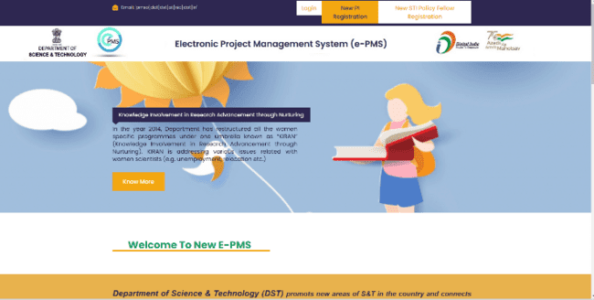

Step 2: Please provide a valid email address in the search box. Please prefer to fill your personal email ID here which you can continue irrespective of your organisational affiliation. After entering the email ID click on search. After that ‘Add User’ button will appear, click on that.

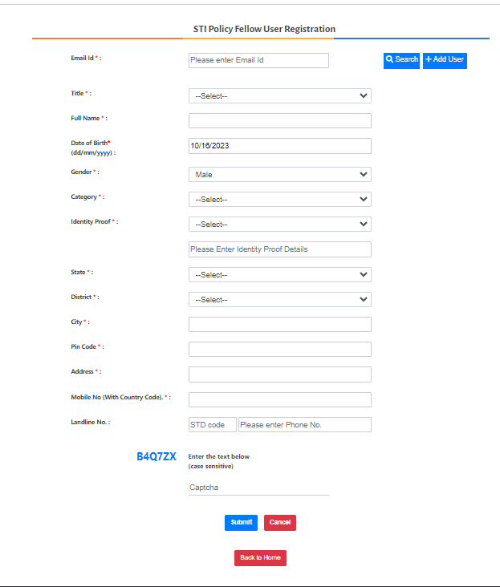
Step 3: Please fill all the fields that are marked as essential and then click on ‘Submit’. An e-mail will be received acknowledging the registration along with the web-link for generating the password

Step 4: You can proceed further to fill the application for the DST-STI Policy Fellowship using the login credentials received through email:

Step 5: After login, the following window will appear.

Step 6: Click on the ‘Submit Proposals’ option followed by ‘Initiate New Proposal’ in the next step.
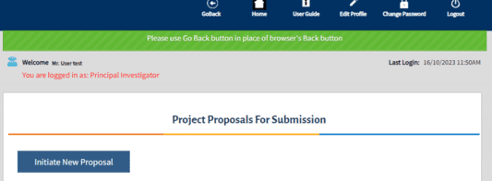

Step 7: Select ‘PCPM’ Division in the drop-down box as presented below:

Step 8: Again select ‘DST STI Policy Fellowship Programme’ in drop down box for Programme/Scheme.

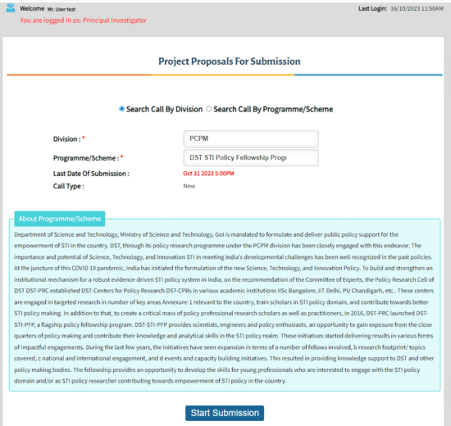
Step 9: Click on Start Submission to fill the form

Step 10: After filling all details, please click on the ‘Preview’ button to verify the details filled in the application form as above.

Step 11: Click on the Declaration check box and click on ‘Print & Submit’ for the Final submission of the application. After submission, no modifications/changes will be allowed. Therefore, the candidate must ensure that all the fields are filled carefully.




